**Assignment 4**

**Create illustrating the Test-Driven Development (TDD) process. Highlight steps like writing tests before code, benefits such as bug reduction, and how it fosters software reliability.**

**Test Driven Development (TDD):**

Test-Driven Development (TDD) is a software development methodology that emphasizes writing tests before writing the actual code. The main idea behind TDD is to create a feedback loop that guides the development process and helps ensure the reliability and correctness of the software being developed. TDD follows a cyclical pattern, often referred to as the “Red-Green-Refactor” cycle, which consists of the following steps:

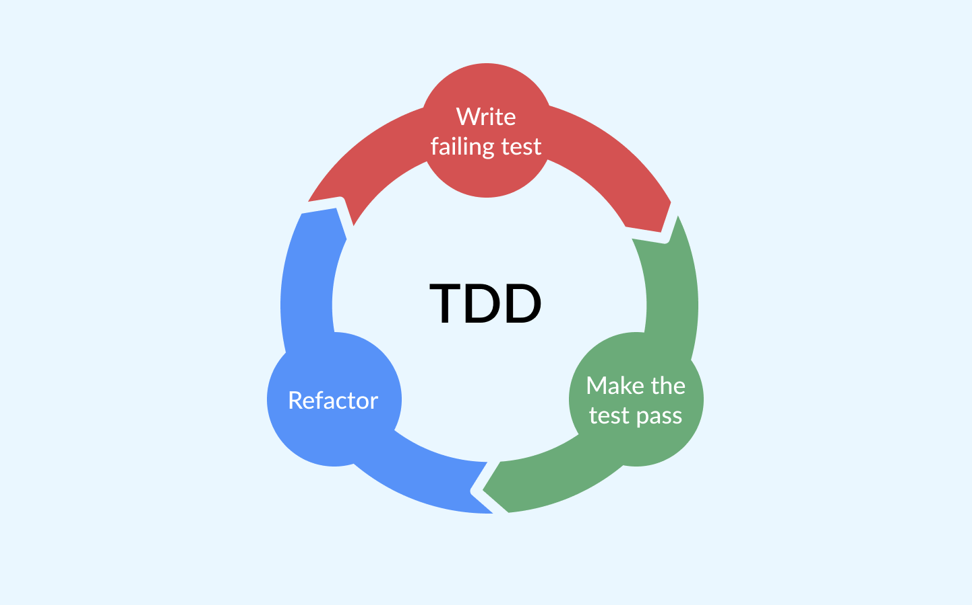

**1.Writing the test first (Red Phase)**

The first step in the TDD process is to write a test that verifies the code's behavior. This test is written before the actual code is written and must fail before the code is written. This ensures that the test is valid and tests the correct behavior.

When writing a test, it is important to keep it as simple as possible. Tests should be written to verify one specific piece of functionality, and each test should be independent of other tests. This helps to ensure that the tests are easy to understand and modify.

**2.Make the Test Pass (Green Phase)**

Once the test is written, the next step is to write the code that passes the test. This code should be written to pass the test and nothing more. This helps ensure that the code is focused on the specific functionality being tested and is not overly complex.

When writing the code, it is important to keep it as simple as possible. The code should be easy to understand, and it should not include any unnecessary complexity. This ensures the code is maintainable over time

**3.Refactor the Code (Refactor Phase)**

The final step in the TDD process is to refactor the code and improve its design. This is a crucial step as it ensures that the code is maintainable over time and that it is easy to modify and extend.

When refactoring the code, it is important to keep the tests passing at all times. This ensures the code is still working as intended and that any changes to the codebase do not break existing functionality.

**Test-Driven Development (TDD)** is a software development approach where tests are written *before* any functional code. This method begins by defining the desired behavior through a failing test, followed by writing just enough code to make that test pass. Once the test is successful, the code is refactored to improve structure and maintainability, ensuring all tests continue to pass. This cycle not only reduces bugs early in the development process but also promotes cleaner, more modular code. By continuously validating the software's functionality, TDD fosters greater reliability, making the codebase more robust and easier to maintain over time.